
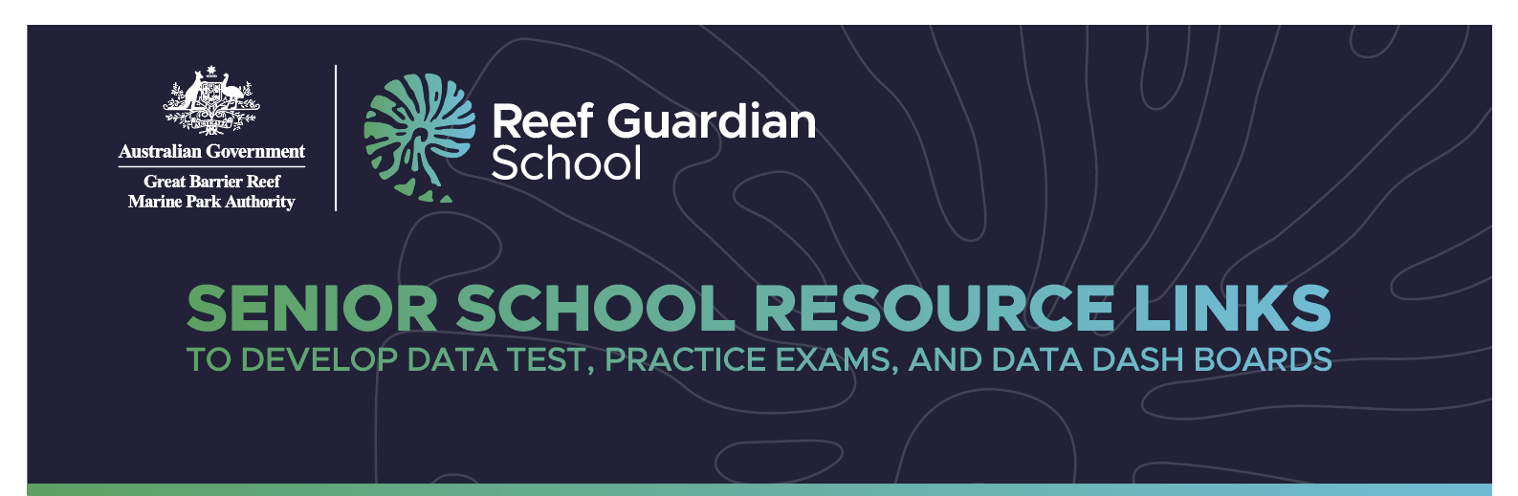

Topic | Name | Description | Data Source | Link
Marine Monitoring: inshore regions of the GBR Marine Park | Marine Monitoring Program | The Great Barrier Reef Marine Monitoring Program (MMP) is focused on the Inshore region of the Great Barrier Reef Marine Park. It reports on the condition of inshore water quality, coral, and seagrass habitats. | Great Barrier Reef Marine Park Authority (Reef Authority) | Marine Monitoring Program  GBRMPA ELibrary: Marine Monitoring Program Annual Report 2021-22 Inshore Coral Reef Monitoring  JCU MMP flood monitoring report
Great Barrier Reef metadata | Reef Knowledge System | Reef Knowledge System Data: This is a search engine tool for Great Barrier Reef metadata and other information such as data and reports. The tool is still in development and will evolve over time. | Great Barrier Reef Marine Park Authority (Reef Authority) | Reef Knowledge System
Sea Surface Temperatures | ReefTemp Next Generation | ReefTemp Next Generation is a set of high-resolution mapping products that provide information on coral bleaching risk for the Great Barrier Reef region. The system was developed by the Bureau of Meteorology for eReefs. | Bureau of Meteorology (BOM) | ReefTemp - BOM
Climate | Climate monitoring graphs | Timeseries graphs of key atmosphere and ocean variables that indicate or influence Australian climate. | Bureau of Meteorology (BOM) | Climate monitoring graphs - BOM
Climate | Australia’s coral Reefs under threat from climate change | Report of Climate Change and Australia’s Coral Reefs | Climate Council | Climate Council
Hydrodynamic & Biogeochemical models of GBR | eReefs AIMS Visualisation Portal | In this portal you will find a range of visualisations of the eReefs Hydrodynamic and BioGeoChemical models of the Great Barrier Reef. These models are like weather models, but for the marine environment, providing a picture of the current and historical environmental conditions on the GBR. | Australian Institute of Marine Science (AIMS) | eReefs AIMS Visualisation Portal
Seagrass monitoring | Seagrass-Watch | Seagrass - Watch global seagrass monitoring. | Seagrass Watch | Global Seagrass Monitoring
Wet Tropics Waterways health | Wet Tropics Dashboard and Report Cards | The Wet Tropics Report Card assesses the conditions of the regions nine catchment areas and eight estuaries, as well as inshore marine and offshore marine zones. | Wet Tropics Waterways | Dashboard: Wet Tropics Waterway Health Report Card  Report Card - Wet Tropics Waterways
Townsville’s Dry Tropics Catchments and waterways. | Townsville Dry Tropics Waterways Report Card 2023 | Each year, the Dry Tropics Partnership for Healthy Waters gathers and evaluates environmental data sourced in our region to present an overview of the most recent condition of local waterway environments.  The Technical Report presents the data collation and analysis behind the 2023 Townsville Dry Tropics Waterways Report Card. | Townsville Dry Tropics | Waterways Report Card 2023 | Dry Tropics Partnership for Healthy Waters  2023 Technical Report | Dry Tropics Partnership for Healthy Waters
Mackay Healthy Rivers to Reef Partnership – Stewardship and Waterways. | Healthy Rivers to Reef stewardship report and waterways report card 2023 | 2023 stewardship Report showcasing the stewardship initiatives their partners are involved in from investment, monitoring, on-ground action and everything in between.  The 2023 Report Card assessed the conditions of waterways in the Mackay – Whitsunday- Isaac region based on data collected between July 2021 and June 2022. | Healthy Rivers to Reef | Above and Beyond - Stewardship Report | Healthy Rivers to Reef Partnership  Latest Report Card | Healthy Rivers to Reef Partnership
Fitzroy Partnership for River Health - Ecosystem Health Index & Pollutant discharge | Fitzroy Basin Eco-system health index | The health of the 11 freshwater catchments of the Fitzroy Basin and the estuary zone are assessed using an Ecosystem Health Index (EHI). This flagship report collates data that is independently assessed to provide a snapshot of how healthy these systems are. | Fitzroy Partnership for River Health | Fitzroy Partnership for River Health Report Card 2021-2022  Fitzroy-ERTs-2015_11_15.pdf (riverhealth.org.au)
Gladstone Healthy Harbour Partnership - Environmental, Economic, Social and Cultural health. | The 2022 Gladstone Harbour Report Card | The 2022 Gladstone Harbour Report Card is the eighth annual Report Card released by the Gladstone Healthy Harbour Partnership (GHHP) and provides a holistic assessment of the harbour’s Environmental, Economic, Social and Cultural health. | Gladstone Healthy Harbour Partnership | 2022 Report Card | Gladstone Healthy Harbour Partnership (ghhp.org.au)
Paddock to Reef program – water quality | Paddock monitoring and modelling reports | The Paddock to Reef Integrated Monitoring, Modelling and Reporting Program provides the framework for evaluating and reporting progress towards Reef 2050 Water Quality Improvement Plan (Reef 2050 WQIP) targets through the Reef water quality report card. | Paddock to Reef | Paddock monitoring and modelling reports  Home | Paddock to Reef Data Portal
Fisheries | Fishery status reports map data | The annual ABARES Fishery Status Reports are an independent assessment of the biological status of commercial fish stocks and the economic status of fisheries managed, or jointly managed, by the Australian Government. | Department of Agriculture, Fisheries and Forestry (DAFF) | Fishery status reports map data - DAFF
Fisheries | Australian fisheries and aquaculture statistics 2021 | Statistical tables of fisheries and aquaculture production for Australia. | Department of Agriculture, Fisheries and Forestry (DAFF) | Statistical Tables - Fisheries and Aquaculture
Recreational Fishing | Recreational Fishing Survey | The Australian Government and Fisheries Research and Development Corporation (FRDC) have funded the National Social and Economic Survey of Recreational Fishers. The aim of the study was to better understand the social and economic contributions of recreational fishing in Australia. | Fisheries Research and Development Corporation (FRDC). | Recreational Fishing Survey | FRDC  National Social and Economic Survey of Recreational Fishers - Final Report  2019-2021 National Recreational Fishing Survey  National Recreational Fishing Bait and Berley Survey 2019-21  Social and Economic Survey of Recreational Fishers 2018-2021  What are the economic benefits of recreational fishing? | FRDC  What are the potential health and wellbeing benefits of recreational fishing? | FRDC
Great Barrier Reef Outlook | Great Barrier Reef Outlook Report 2019 | Every five years, the Reef Authority publishes an Outlook Report that examines the Great Barrier Reef’s health, pressures, and likely future. | Great Barrier Reef Marine Park Authority (Reef Authority) | Great Barrier Reef Outlook Report 2019
Crown-of-Thorns Starfish Control Program | Crown-of-Thorns Starfish project dashboard | The crown-of-thorns starfish (COTS) project dashboard contains current information regarding the crown-of-thorns control programme including COTS outbreak status, live coral cover and culling activity metrics. | Great Barrier Reef Marine Park Authority (Reef Authority) | Crown-of-thorns starfish project dashboard
Coastal changes to shorelines | Digital Earth Australia Coastlines | Digital Earth Australia Coastlines (DEA Coastlines) is a continental dataset that includes annual shorelines and rates of coastal change along the entire Australian coastline from 1988 to the present. | Digital Earth Australia | Digital Earth Australia Map
Queensland Tourism Research and Insights | Tourism and Events Queensland, Overview and Regional Snapshots | Tourism and Events Queensland analyses data and conducts research on a variety of aspects of the tourism industry to provide data and insight to assist various stakeholders with decision making and strategy development. | Tourism and Events Queensland | Research and insights | Tourism and Events Queensland  Tourism Data Explorer | Tourism and Events Queensland
Reef protection regulation compliance | Queensland Government | The following dashboard details is compliance data for the department’s engagement with sugarcane and banana producers, and graziers in the Great Barrier Reef catchment. This information is current as of June 2022. | Queensland Government | Compliance dashboard | Environment, land and water | Queensland Government
Environment and Economy | National Ocean Ecosystems Account | Environmental-Economic Accounting (EEA) helps us understand the condition of our environment and its relationship with our economy The development of a public dashboard identifies the state of our key natural capital assets, such as land, water and ecosystems. | Department of Climate Change, Energy, the Environment and Water | Environmental-Economic Accounting Dashboard  National Ocean Ecosystem Account

